《操作系统综合实验》
实 验 报 告 书

学 生 姓 名 xxxxxx
学 号 xxxxxxxxxxx
班 级 xxxxxxx

2020 — 2021 学年 第 2 学期

《操作系统综合实验》实验报告
实验名称 | 多进程编程 | 实验序号 |  | 2
实验日期 | 2021.6 |  | 实验人 |  | Xxx
一、实验题目
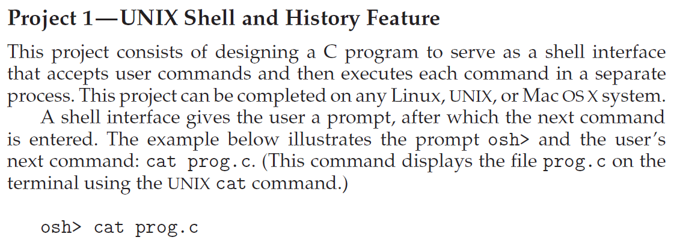
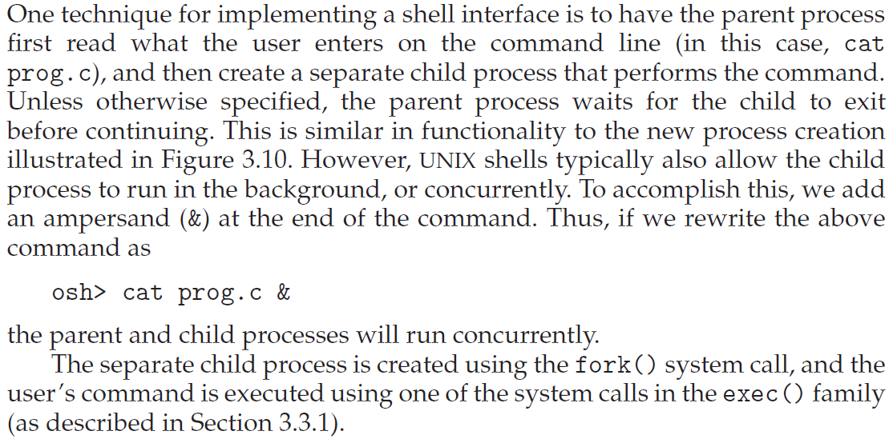

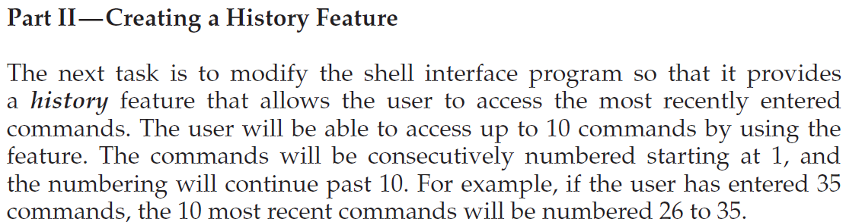
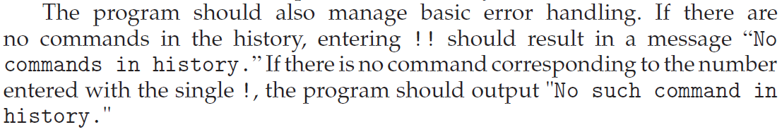

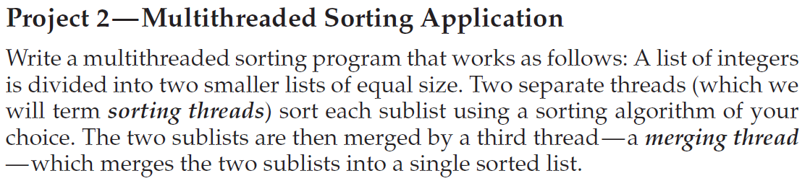

二、相关原理与知识
- 进程的概念、基本状态、进程控制块及其控制相关的信息；
- 进程调度及调度队列与调度程序；
- 进程的创建、中断和终止；
- C语言编程与数据结构的基本知识

三、实验过程

从以下头文件中选择函数完成代码的设计：
<stdio.h>：标准输入/输出函数，清除缓冲区的函数fflush()等
<wait.h>：系统调用函数wait()
<unistd.h>：文件执行函数execvp()，用于shell的职能
<stdlib.h>：退出函数exit()等
<string.h>：处理字符串的函数，如strcmp,strcpy等。
完成Shell之后，再完成描述历史特征的函数displayHistory()，该函数的内容如下：
void displayHistory()
{
printf("Shell command history:\n");
int i;
int j = 0;
int histCount = count; //loop for iterating through commands
for (i = 0; i<10;i++)
{
//command index
printf("%d. ", histCount);
while (history[i][j] != '\n' && history[i][j] != '\0')
{
printf("%c", history[i][j]); //printing command
j++;
}
printf("\n");
j = 0;
histCount--;
if (histCount == 0)
break;
}
printf("\n");
}

四、实验结果与分析
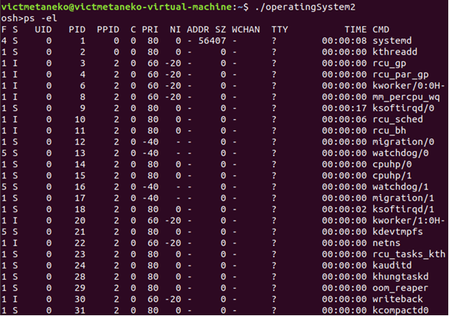
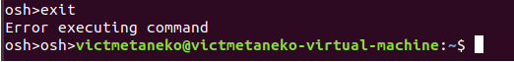
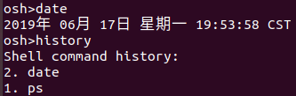
五、问题总结
1. 编译显示wait()未引用
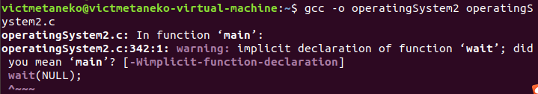
解决方案：在源代码的开头加入 #include <wait.h>；
2. 无法通过exit命令退出osh
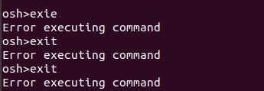
解决方案：在源代码的main函数中，以should_run为判断条件的while循环体中加入如下语句：
if(strcmp(args[0],"exit")==0) {should_run=0;continue;}

六、源代码
- #include <stdio.h>
- #include <wait.h>
- #include <unistd.h>
- #include <stdlib.h>
- #include <string.h>
- #define MAX_LINE 80 /* The maximum length of a command */
- #define BUFFER_SIZE 50
- #define buffer "\n\Shell Command History:\n"
- //declarations
- char history[10][BUFFER_SIZE];
- //history array to store history commands
- int count = 0;
- //function to display the history of commands
- void displayHistory()
- {
- printf("Shell command history:\n");
- int i;
- int j = 0;
- int histCount = count;
- //loop for iterating through commands
- for (i = 0; i<10;i++)
- {
- //command index
- printf("%d. ", histCount);
- while (history[i][j] != '\n' && history[i][j] != '\0')
- {
- //printing command
- printf("%c", history[i][j]);
- j++;
- }
- printf("\n");
- j = 0;
- histCount--;
- if (histCount == 0)
- break;
- }
- printf("\n");
- }

- int formatCommand(char inputBuffer[], char *args[],int *flag)
- {
- int length; // # of chars in command line
- int i;
- // loop index for inputBuffer
- int start; // index of beginning of next command
- int ct = 0; // index of where to place the next parameter into args[]
- int hist;
- length = read(STDIN_FILENO, inputBuffer, MAX_LINE);
- start = -1;
- if (length == 0)
- exit(0);
- //end of command
- if (length < 0)
- {
- printf("Command not read\n");
- exit(-1); //terminate

- }
- //examine each character

- for (i=0;i<length;i++)

- {

- switch (inputBuffer[i])

- {

- case ' ':

- case '\t' :
- // to seperate arguments

- if(start != -1)

- {

- args[ct] = &inputBuffer[start];

- ct++;

- }

- inputBuffer[i] = '\0'; // add a null char at the end

- start = -1;

- break;

- case '\n':
- //final char

- if (start != -1)

- {

- args[ct] = &inputBuffer[start];

- ct++;

- }

- inputBuffer[i] = '\0';

- args[ct] = NULL; // no more args

- break;

- default :

- if (start == -1)

- start = i;

- if (inputBuffer[i] == '&')

- {

- *flag = 1;

- inputBuffer[i] = '\0';

- }

- }

- }

- args[ct] = NULL; //if the input line was > 80

- if(strcmp(args[0],"history")==0)
- {

- if(count>0)

- {

- displayHistory();

- }

- else

- {

- printf("\nNo Commands in the history\n");

- }

- return -1;

- }

- else if (args[0][0]-'!' ==0)

- {

- int x = args[0][1]- '0';
- int z = args[0][2]- '0';

- if(x>count) //second letter check

- {

- printf("\nNo Such Command in the history\n");

- strcpy(inputBuffer,"Wrong command");

- }

- else if (z!=-48) //third letter check

- {

- printf("\nEnter <=!9(buffer size is 10 along with current command)\n");

- strcpy(inputBuffer,"Wrong command");
- }

- else

- {

- if(x==-15)

- {

- strcpy(inputBuffer,history[0]); // this will be your 10 th(last) command

- }

- else if(x==0) //Checking for '!0'

- {

- printf("Enter proper command");

- strcpy(inputBuffer,"Wrong command");

- }

- else if(x>=1) //Checking for '!n', n >=1

- {

- strcpy(inputBuffer,history[count-x]);

- }

- }

- }

- for (i = 9;i>0; i--) //Moving the history elements one step higher

- strcpy(history[i], history[i-1]);

- strcpy(history[0],inputBuffer); //Updating the history array with input buffer

- count++;

- if(count>10)

- { count=10;}
- }

- int main(void)
- {

- char inputBuffer[MAX_LINE]; /* buffer to hold the input command */

- int flag; // equals 1 if a command is followed by "&"

- char *args[MAX_LINE/2 + 1];/* max arguments */

- int should_run =1;

- pid_t pid,tpid;

- int i;

- while (should_run) //infinite loop for shell prompt

- {

- flag = 0; //flag =0 by default

- printf("osh>");

- fflush(stdout);

- if(strcmp(args[0],"exit")==0) {should_run=0;continue;}
- if(-1!=formatCommand(inputBuffer,args,&flag)) // get next command

- {

- pid = fork();

- if (pid < 0)//if pid is less than 0, forking fails

- {

- printf("Fork failed.\n");

- exit (1);

- }

- else if (pid == 0)//if pid ==0

- {
- //command not executed

- if (execvp(args[0], args) == -1)

- {

- printf("Error executing command\n");

- }

- }

- // if flag == 0, the parent will wait,

- // otherwise returns to the formatCommand() function.

- else

- {

- i++;

- if (flag == 0)

- {

- i++;

- wait(NULL);

- }

- }

- }

- }

- }

